LAPORAN HASIL PRAKTIKUM

DAN PEMROGAMAN

JOBSHEET 1



RIFO ANGGI BARBARA DANUARTA

244107020063

TI_1E

PROGRAM STUDI D_IV TEKNIK INFORMATIKA

JURUSAN TEKNOLOGI INFORMASI

POLITEKNIK NEGERI MALANG

1. Pemilihan

Kode Program

import java.util.Scanner;

public class Pemilihan {

public static void main(String[] args) {

Scanner sc = new Scanner(System.in);

double nilaiAkhir;

String nilaiHuruf;

System.out.println("Program Menghitung Nilai Akhir");

System.out.println("======================");

System.out.print("Masukan Nilai Tugas: ");

int nilaiTugas = sc.nextInt();

System.out.print("Masukan Nilai Kuis: ");

int nilaiKuis = sc.nextInt();

System.out.print("Masukan Nilai UTS: ");

int nilaiUts = sc.nextInt();

System.out.print("Masukan Nilai UAS: ");

int nilaiUas = sc.nextInt();

System.out.println("======================");

System.out.println("======================");

if (nilaiTugas < 0 || nilaiTugas > 100 ) {

System.out.println("Nilai Tidak Valid");

return;

}

if (nilaiKuis < 0 || nilaiKuis > 100 ) {

System.out.println("Nilai Tidak Valid");

return;

}

if (nilaiUts < 0 || nilaiUts > 100 ) {

System.out.println("Nilai Tidak Valid");

return;

}

if (nilaiUas < 0 || nilaiUas > 100 ) {

System.out.println("Nilai Tidak Valid");

return;

}

nilaiAkhir = (nilaiTugas * 20/100) + (nilaiKuis * 20/100) + (nilaiUts * 30/100) + (nilaiUas * 30/100);

System.out.println("Nilai Akhir : " + nilaiAkhir);

System.out.print("Nilai Huruf : ");

if (nilaiAkhir >= 80 && nilaiAkhir < 100 ) {

System.out.println("A");

} else if (nilaiAkhir >= 73 && nilaiAkhir < 80 ) {

System.out.println("B+");

} else if (nilaiAkhir >= 65 && nilaiAkhir < 73 ) {

System.out.println("B");

} else if (nilaiAkhir >= 60 && nilaiAkhir < 65 ) {

System.out.println("C+");

} else if (nilaiAkhir >= 50 && nilaiAkhir < 60 ) {

System.out.println("C");

} else if (nilaiAkhir >= 39 && nilaiAkhir < 50 ) {

System.out.println("D");

} else if (nilaiAkhir <= 39 ) {

System.out.println("E");

}

System.out.println("======================");

System.out.println("======================");

if (nilaiAkhir >= 39) {

System.out.println("SELAMAT ANDA LULUS");

} else {

System.out.println("ANDA TIDAK LULUS");

}

}

}

Hasil Output

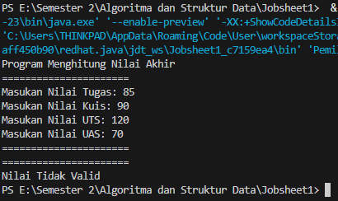

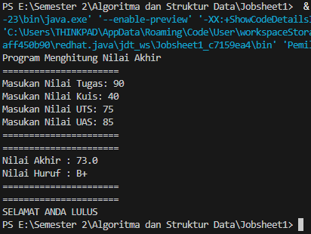

1. Perulangan

Kode Program

import java.util.Scanner;

public class Perulangan {

public static void main(String[] args) {

Scanner sc = new Scanner(System.in);

System.out.print("Masukan Nim : ");

String nim = sc.nextLine();

System.out.print("Masukan 2 Digit Nim Belakang : ");

int n = sc.nextInt();

System.out.println("================================");

if (n < 10) {

n += 10;

}

for (int i = 1; i <= n; i++) {

if (i == 6 && i == 10) {

continue;

} if (i % 2 != 0) {

System.out.print("* ");

} else {

System.out.print(i + " ");

}

}

}

}

Hasil Output

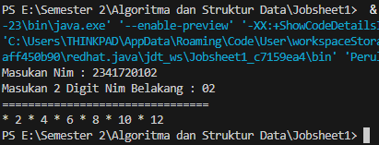

1. Array

import java.util.Scanner;

public class array {

public static void main(String[] args) {

Scanner sc = new Scanner(System.in);

System.out.println("======================");

System.out.println("Program Menghitung IP Semester");

System.out.println("======================");

System.out.print("Masukkan nilai Angka untuk MK Pancasila: ");

double nilaiPan = sc.nextDouble();

System.out.print("Masukkan nilai Angka untuk MK Konsep Teknologi Informasi: ");

double nilaiKti = sc.nextDouble();

System.out.print("Masukkan nilai Angka untuk MK Critical Thinking dan Problem Solving: ");

double nilaiCtps = sc.nextDouble();

System.out.print("Masukkan nilai Angka untuk MK Matematika Dasar: ");

double nilaiMat = sc.nextDouble();

System.out.print("Masukkan nilai Angka untuk MK Bahasa Inggris: ");

double nilaiBing = sc.nextDouble();

System.out.print("Masukkan nilai Angka untuk MK Dasar Pemrograman: ");

double nilaiDas = sc.nextDouble();

System.out.print("Masukkan nilai Angka untuk MK Praktikum Dasar Pemrograman: ");

double nilaiPrak = sc.nextDouble();

System.out.print("Masukkan nilai Angka untuk MK Keselamatan dan Kesehatan Kerja: ");

double nilaiK3 = sc.nextDouble();

String[] matkul = {

"Pancasila", "Konsep Teknologi Informasi", "Critical Thinking dan Problem Solving",

"Matematika Dasar", "Bahasa Inggris", "Dasar Pemrograman",

"Praktikum Dasar Pemrograman", "Keselamatan dan Kesehatan Kerja"

};

double[] nilai = {nilaiPan, nilaiKti, nilaiCtps, nilaiMat, nilaiBing, nilaiDas, nilaiPrak, nilaiK3};

String[] nilaiHuruf = new String[8];

double[] nilaiAngka = new double[8];

for (int i = 0; i < nilai.length; i++) {

if (nilai[i] >= 80) {

nilaiHuruf[i] = "A";

nilaiAngka[i] = 4.00;

} else if (nilai[i] >= 73) {

nilaiHuruf[i] = "B+";

nilaiAngka[i] = 3.50;

} else if (nilai[i] >= 65) {

nilaiHuruf[i] = "B";

nilaiAngka[i] = 3.00;

} else if (nilai[i] >= 60) {

nilaiHuruf[i] = "C+";

nilaiAngka[i] = 2.50;

} else if (nilai[i] >= 50) {

nilaiHuruf[i] = "C";

nilaiAngka[i] = 2.00;

} else if (nilai[i] >= 39) {

nilaiHuruf[i] = "D";

nilaiAngka[i] = 1.00;

} else {

nilaiHuruf[i] = "E";

nilaiAngka[i] = 0.00;

}

}

double totalNilai = 0;

for (int i = 0; i < nilai.length; i++) {

totalNilai += nilaiAngka[i];

}

double ipSemester = totalNilai / nilai.length;

System.out.println("======================");

System.out.println("Hasil Konversi Nilai");

System.out.println("======================");

System.out.println("MK\t\t\t\t\tNilai Angka\tNilai Huruf\tBobot Nilai");

for (int i = 0; i < nilai.length; i++) {

System.out.printf("%-40s\t%.2f\t%-10s\t%.2f\n", matkul[i], nilai[i], nilaiHuruf[i], nilaiAngka[i]);

}

System.out.printf("\nIP Semester: %.2f\n", ipSemester);

sc.close();

}

}

Hasil Output

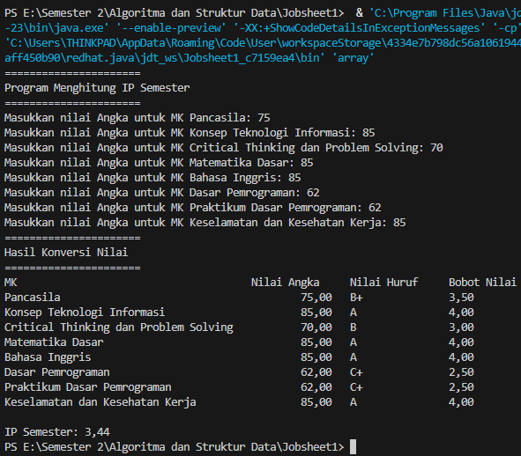

1. Fungsi

public class fungsi {

public static void main(String[] args) {

int[][] stock = {

{10, 5, 15, 7},

{6, 11, 9, 12},

{2, 10, 10, 5},

{5, 7, 12, 5}

};

int[] harga = {75000, 50000, 60000, 10000};

int[] pengurangan = {1, 2, 0, 5};

for (int i = 0; i < stock.length; i++) {

int pendapatan = 0;

for (int j = 0; j < stock[i].length; j++) {

pendapatan += stock[i][j] * harga[j];

}

System.out.println("Pendapatan RoyalGarden " + (i + 1) + " adalah: " + pendapatan);

}

System.out.println("\nStock RoyalGarden 4 sebelum pengurangan:");

tampilkanStock(stock[3]);

for (int i = 0; i < stock[3].length; i++) {

stock[3][i] -= pengurangan[i];

}

System.out.println("\nStock RoyalGarden 4 setelah pengurangan:");

tampilkanStock(stock[3]);

}

public static void tampilkanStock(int[] stock) {

String[] jenisBunga = {"Aglonema", "Keladi", "Alocasia", "Mawar"};

for (int i = 0; i < stock.length; i++) {

System.out.println(jenisBunga[i] + ": " + stock[i]);

}

}

}

Hasil Output

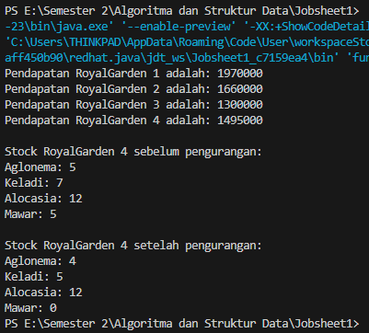

Tugas 1

import java.util.Scanner;

public class tugas1 {

public static void main(String[] args) {

char[] KODE = {'A', 'B', 'D', 'E', 'F', 'G', 'H', 'L', 'N', 'T'};

char[][] KOTA = {

{'B', 'A', 'N', 'T', 'E', 'N'},

{'J', 'A', 'K', 'A', 'R', 'T', 'A'},

{'B', 'A', 'N', 'D', 'U', 'N', 'G'},

{'C', 'I', 'R', 'E', 'B', 'O', 'N'},

{'B', 'O', 'G', 'O', 'R'},

{'P', 'E', 'K', 'A', 'L', 'O', 'N', 'G', 'A', 'N'},

{'S', 'E', 'M', 'A', 'R', 'A', 'N', 'G'},

{'S', 'U', 'R', 'A', 'B', 'A', 'Y', 'A'},

{'M', 'A', 'L', 'A', 'N', 'G'},

{'T', 'E', 'G', 'A', 'L'}

};

Scanner sc = new Scanner(System.in);

System.out.print("Masukkan kode plat mobil (misalnya A, B, D, E, F, G, H, L, N, T): ");

char inputKode = sc.next().charAt(0);

boolean ditemukan = false;

for (int i = 0; i < KODE.length; i++) {

if (KODE[i] == inputKode) {

System.out.print("Kota dengan kode plat " + inputKode + " adalah: ");

for (int j = 0; j < KOTA[i].length; j++) {

System.out.print(KOTA[i][j]);

}

System.out.println();

ditemukan = true;

break;

}

}

if (!ditemukan) {

System.out.println("Kode plat mobil tidak valid atau tidak ada dalam daftar.");

}

}

}

Hasil Output

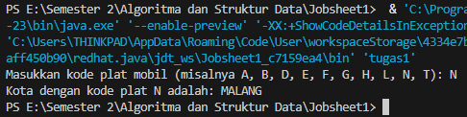

Tugas 2

import java.util.Scanner;

public class tugas2 {

public static void tampilkanMenu() {

System.out.println("Pilih Rumus Yang akan Di Hitung : ");

System.out.println("1. Perhitungan Volume Kubus ");

System.out.println("2. Perhitungan Luas Permukaan Kubus ");

System.out.println("3. Perhitungan Keliling Kubus ");

System.out.println("4. Keluar");

}

public static double perhitunganVolumeKubus(double sisi) {

return sisi * sisi * sisi;

}

public static double perhitunganLuasKubus(double sisi) {

return sisi * sisi * 6;

}

public static double perhitunganKelilingKubus(double sisi) {

return sisi * 12;

}

public static void main(String[] args) {

Scanner sc = new Scanner(System.in);

int pilihan;

double sisi;

while (true) {

tampilkanMenu();

System.out.print("Masukkan Pilihan (1/2/3/4): ");

pilihan = sc.nextInt();

if (pilihan == 4) {

System.out.println("Keluar dari program.");

break;

}

System.out.print("Masukkan Panjang Sisi: ");

sisi = sc.nextDouble();

switch (pilihan) {

case 1:

System.out.println("Volume Kubus: " + perhitunganVolumeKubus(sisi));

break;

case 2:

System.out.println("Luas Kubus: " + perhitunganLuasKubus(sisi));

break;

case 3:

System.out.println("Keliling Kubus: " + perhitunganKelilingKubus(sisi));

break;

default:

System.out.println("Pilihan Tidak Valid.");

break;

}

System.out.println();

}

sc.close();

}

}

Hasil Output

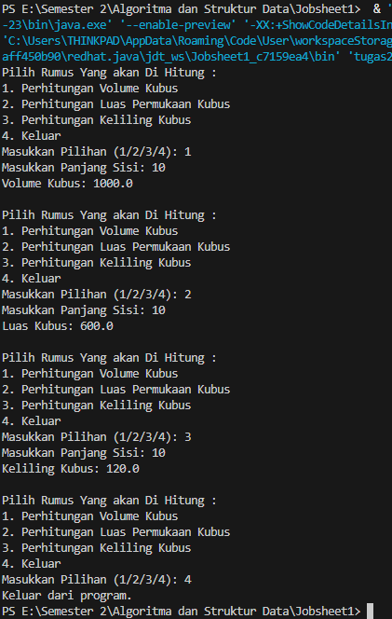

Tugas 3

import java.util.Scanner;

public class tugas3 {

public static Scanner sc = new Scanner(System.in);

public static void inputDataMatkul(

int n, String namaMatkul[], int sksMatkul[], int semesterMatkul[], String hariMatkul[]) {

for (int i = 0; i < n; i++) {

System.out.print("Masukkan Nama Mata Kuliah: ");

namaMatkul[i] = sc.nextLine();

System.out.print("Masukkan SKS Mata Kuliah: ");

sksMatkul[i] = sc.nextInt();

System.out.print("Masukkan Semester Mata Kuliah: ");

semesterMatkul[i] = sc.nextInt();

sc.nextLine();

System.out.print("Masukkan Hari Mata Kuliah: ");

hariMatkul[i] = sc.nextLine();

}

}

public static void printDataMatkul(

int n, String namaMatkul[], int sksMatkul[], int semesterMatkul[], String hariMatkul[]) {

System.out.printf("%-40s %-20s %-20s %-20s\n", "Mata Kuliah", "SKS", "Semester", "Hari");

System.out.println("-----------------------------------------------------------------------------------------------");

for (int i = 0; i < namaMatkul.length; i++) {

System.out.printf(

"%-40s %-20d %-20d %-20s\n",

namaMatkul[i], sksMatkul[i], semesterMatkul[i], hariMatkul[i]);

}

}

public static void mencariHari(

int n,

String namaMatkul[],

int sksMatkul[],

int semesterMatkul[],

String hariMatkul[],

String inputHari) {

System.out.printf("%-40s %-20s %-20s %-20s\n", "Mata Kuliah", "SKS", "Semester", "Hari");

System.out.println("-----------------------------------------------------------------------------------------------");

boolean found = false;

for (int i = 0; i < namaMatkul.length; i++) {

if (hariMatkul[i].equalsIgnoreCase(inputHari)) {

System.out.printf(

"%-40s %-20d %-20d %-20s\n",

namaMatkul[i], sksMatkul[i], semesterMatkul[i], hariMatkul[i]);

found = true;

}

}

if (!found) {

System.out.println("Data mata kuliah pada hari " + inputHari + " tidak ditemukan");

}

}

public static void mencariSemester(

int n,

String namaMatkul[],

int sksMatkul[],

int semesterMatkul[],

String hariMatkul[],

int semester) {

System.out.printf("%-40s %-20s %-20s %-20s\n", "Mata Kuliah", "SKS", "Semester", "Hari");

System.out.println("-----------------------------------------------------------------------------------------------");

boolean found = false;

for (int i = 0; i < namaMatkul.length; i++) {

if (semesterMatkul[i] == semester) {

System.out.printf(

"%-40s %-20d %-20d %-20s\n",

namaMatkul[i], sksMatkul[i], semesterMatkul[i], hariMatkul[i]);

found = true;

}

}

if (!found) {

System.out.println("Data mata kuliah pada semester " + semester + " tidak ditemukan");

}

}

public static void mencariNama(

int n,

String namaMatkul[],

int sksMatkul[],

int semesterMatkul[],

String hariMatkul[],

String inputNama) {

System.out.printf("%-40s %-20s %-20s %-20s\n", "Mata Kuliah", "SKS", "Semester", "Hari");

System.out.println("-----------------------------------------------------------------------------------------------");

boolean found = false;

for (int i = 0; i < namaMatkul.length; i++) {

if (namaMatkul[i].equalsIgnoreCase(inputNama)) {

System.out.printf(

"%-40s %-20d %-20d %-20s\n",

namaMatkul[i], sksMatkul[i], semesterMatkul[i], hariMatkul[i]);

found = true;

}

}

if (!found) {

System.out.println("Data mata kuliah dengan nama " + inputNama + " tidak ditemukan");

}

}

public static void main(String[] args) {

System.out.print("Masukkan Jumlah Mata Kuliah: ");

int n = sc.nextInt();

String namaMatkul[] = new String[n];

int sksMatkul[] = new int[n];

int semesterMatkul[] = new int[n];

String hariMatkul[] = new String[n];

sc.nextLine();

inputDataMatkul(n, namaMatkul, sksMatkul, semesterMatkul, hariMatkul);

while (true) {

System.out.println("Progam Mata Kuliah");

System.out.println("1. Menampilkan Data Mata Kuliah");

System.out.println("2. Mencari Mata Kuliah Berdasarkan Hari");

System.out.println("3. Mencari Mata Kuliah Berdasarkan Semester");

System.out.println("4. Mencari Mata Kuliah Berdasarkan Nama");

System.out.println("5. Keluar");

System.out.print("Silahkan Pilih Menu Program dibawah ini: ");

int pilihan = sc.nextInt();

sc.nextLine();

switch (pilihan) {

case 1:

printDataMatkul(n, namaMatkul, sksMatkul, semesterMatkul, hariMatkul);

break;

case 2:

System.out.print("Masukkan Hari Mata Kuliah: ");

String inputHari = sc.nextLine();

mencariHari(n, namaMatkul, sksMatkul, semesterMatkul, hariMatkul, inputHari);

break;

case 3:

System.out.print("Masukkan Semester Mata Kuliah: ");

int inputSemester = sc.nextInt();

mencariSemester(n, namaMatkul, sksMatkul, semesterMatkul, hariMatkul, inputSemester);

break;

case 4:

System.out.print("Masukkan Nama Mata Kuliah: ");

String inputNama = sc.nextLine();

mencariNama(n, namaMatkul, sksMatkul, semesterMatkul, hariMatkul, inputNama);

break;

case 5:

System.out.println("Program Selesai");

return;

default:

System.out.println("Pilihan Tidak Tersedia");

break;

}

}

}

}

Hasil Output

